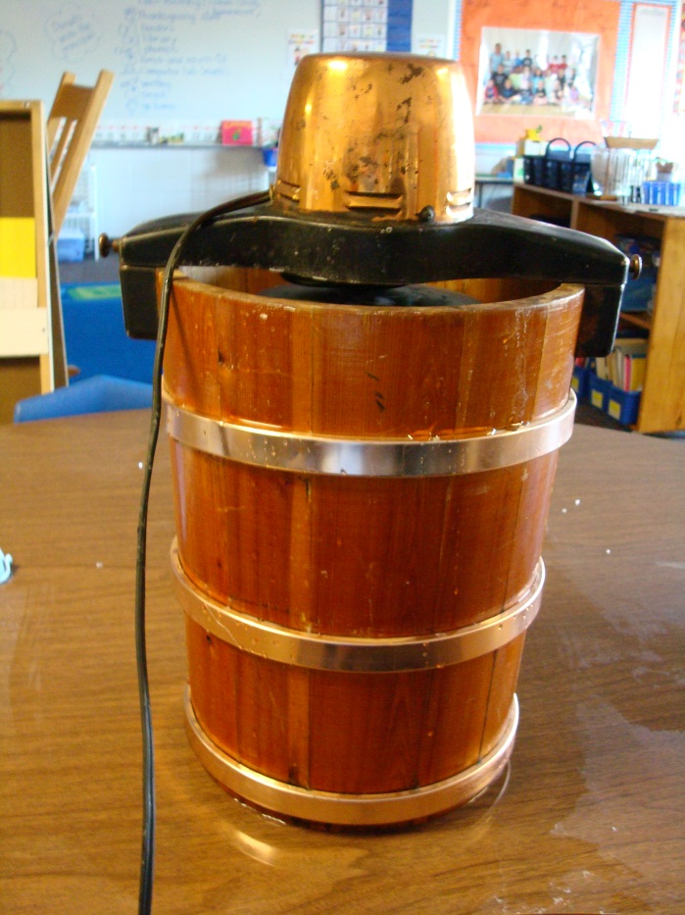

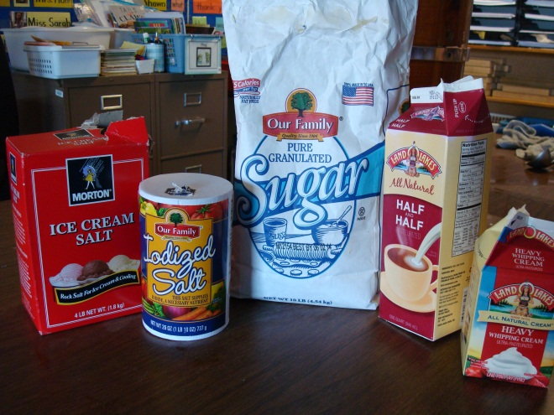

Homemade
Ice Cream
2 quarts half and half
½ pint heavy cream
1 ½ cups sugar
4 teaspoons vanilla
Pinch of salt

Place in ice cream maker. Turn it on. Watch it stir! When it stops your ice cream is done!
Enjoy!

